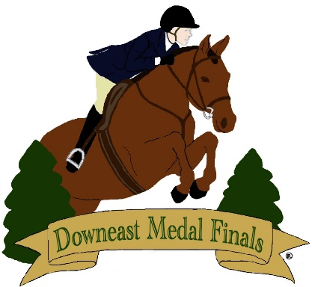

DMF Educational Scholarships

Opening date for applications: July 11

Closing date: July 18

DMF would like to help contribute to our riders’ pursuit of higher education. We are offering three $1,000 scholarships, payable to the school of choice, after submission of successful first semester grades. The award will be used solely for educational expenses.
For the application to be considered the applicant needs to enter and show at DMF 2022. Recipients will be notified at DMF 2022.

Application
Please email a document with the following information to Ginger at Ginger@downeastmedalfinals.com
Name:
Email:
Phone:
Parent’s email:
Parent’s phone:
Junior or adult?
Date of birth:
Name of trainer:
Email of trainer:
Phone number of trainer:
Name of school you are presently attending:
Address of school you are presently attending:
Date of graduation from High School:
Name of school or college you will be/are attending:
Address of school or college you will be/are attending:
Date of entrance to school or college:
What extracurricular activities and volunteer work have you been involved with?

Have you worked to help pay for your lessons, board and show expenses? If so, please list your jobs with contact information of employer

This scholarship is based on need, how will this scholarship help you and your family?

Have you received any other financial assistance for your educational expenses?

Please write an essay outlining how you will carry the spirit of DMF forward with you in the future.

